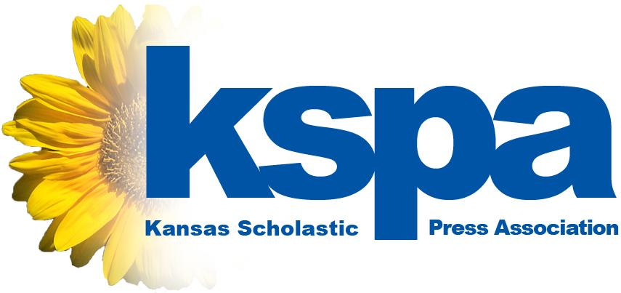

XXXXXXXXX HIGH SCHOOL journalists win big at Regional Contests
State association hands out awards to best entries from thousands of entries

LAWRENCE, March 8, 2016 -- The Kansas Scholastic Press Association is proud to announce the winners of the 2016 Regional Contests, which rewarded the best student journalism from among 2,500 entries gathered from around the state.

In the Regional Contest, students from 86 different schools competed in 19 different categories in 12 different classifications organized by geography and school size. KSPA will award more than 1,400 awards for entries into the contest.

From XXXXXXXXXXXXX High School, the following students won awards:
- STUDENT NAME, CONTEST, PLACE
- STUDENT NAME, CONTEST, PLACE
- STUDENT NAME, CONTEST, PLACE
- STUDENT NAME, CONTEST, PLACE
- STUDENT NAME, CONTEST, PLACE

Six university campuses throughout Kansas hosted the contests Feb. 24 and 25. This year XXXXXXX HIGH SCHOOL competed at the XXXXXXXXXX location.

“We consider the Regional Contests to be one of our most important annual events both for students to receive feedback on their work and also for students to compete with one another,” said Eric Thomas, KSPA executive director. “Teachers who organize and enter their students into the contest give their students a great opportunity to see how their work compares to the work of others.”

KSPA enlists the help of journalism teachers, professional journalists, university faculty members and other journalism experts to judge the entries.

Any student who earns an award in the Regional Contest advances to the KSPA State Contest on May 7 at the University of Kansas. Based on results from the State Contest, KSPA will determine the top school in 1A, 2A, 3A, 4A, 5A and 6A.

###

About KSPA: The Kansas Scholastic Press Association is a non-profit assocation of more than 100 high school and middle school journalism programs. Its mission is to promote excellence in high school journalism publications and education. Please log on to learn more at www.kspaonline.org.

KSPA Contact:
Eric Thomas, executive director
(785) 864-0605
staff@kspaonline.org

