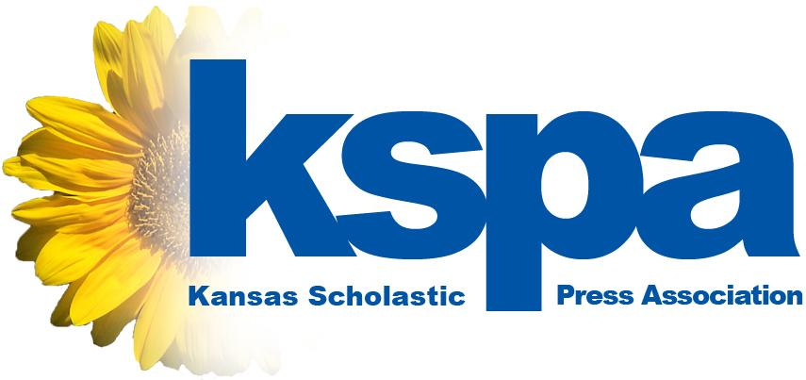

XXXXXXXXX HIGH SCHOOL journalists win at State Contests
State champions crowned in both individual and team categories

LAWRENCE, May 7, 2016 -- The Kansas Scholastic Press Association is proud to announce the winners of the 2016 State Contest, which rewarded the best student journalism from around the state. To earn the chance to compete in the State Contest, students qualified through Regional Contests in February.

In the State Contest, students from 77 different schools competed in 21 different categories in 3 different classifications. KSPA will award more than 350 awards for entries into the contest.

From XXXXXXXXXXXXX High School, the following students won awards:
- STUDENT NAME, CONTEST, PLACE
- STUDENT NAME, CONTEST, PLACE
- STUDENT NAME, CONTEST, PLACE
- STUDENT NAME, CONTEST, PLACE
- STUDENT NAME, CONTEST, PLACE

The University of Kansas hosted the day of the competition at the Kansas Union. Nine different categories, such as editorial writing and sports writing, took place on the day of the contest. Students used notes provided in prompts to inspire their writing and cartooning entries.

Earlier in the weeks, students submitted hundreds of other entries – in 12 different contests – to an online contest that featured design, photography and online categories.

“Seeing the focus and skill of hundreds of students on display during the State Contest is amazing,” said Eric Thomas, KSPA executive director. “All of this talent from all over the state converges on our campus for a one-day competition. While sports have state tournaments, we have this. And it’s equally demanding and prestigious for the students.”

Based on the combined scores of the students from each school, KSPA names a Sweepstakes Champion for each school enrollment size. This year, the following schools earned Sweepstakes Championships:
- 1A: Burrton High School
- 2A: Canton-Galva High School
- 3A: Humboldt High School
- 4A: Hays High School
- 5A: Mill Valley High School
- 6A: Shawnee Mission East High School

KSPA enlists the help of journalism teachers, professional journalists, university faculty members and other journalism experts to judge the entries.
###

About KSPA: The Kansas Scholastic Press Association is a non-profit assocation of more than 100 high school and middle school journalism programs. Its mission is to promote excellence in high school journalism publications and education. Please log on to learn more at www.kspaonline.org.

KSPA Contact:
Eric Thomas, executive director, (785) 864-0605, staff@kspaonline.org

