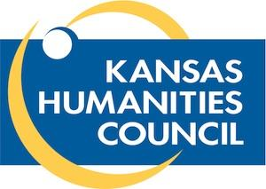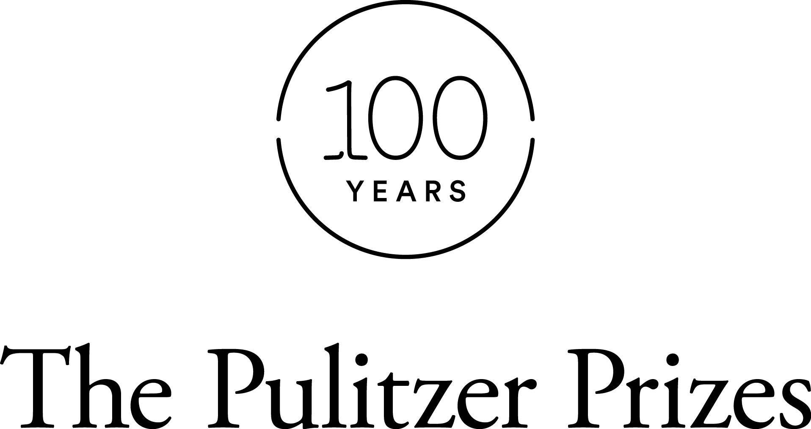

COVERING CONTROVERSY: how student publications reveal the truth
a partnership of the Kansas Scholastic Press Association, the Kansas Humanities Council,
the Pulitzer Prizes, & the Federation of State Humanities Councils

KSPA is partnering with the Kansas Humanities Council to celebrate the 100th anniversary of the Pulitzer Prizes. Kansas has a special connection to the Pulitzer Prizes with William Allen White's editorial winning the 1922 Pulitzer Prize. And this project will connect high school teachers and students with that legacy
KSPA is joining the anniversary celebration by awarding one pairing of student and teacher to travel to each of the fall conference locations to deliver a session about how to cover controversial content in student media. We invite all Kansas high school media advisers and their students to apply.
The writers of the top application will have the chance to tell their stories of covering controversy through a session at the fall conferences. The session will tell the story of the coverage -- from beginning to end. Even more, the second chapter of the session will organize students and advisers around controversy within their schools and communities.
CALL FOR APPLICATIONS
Has your student publication covered an issue or issues of controversy in your community? These controversies might be touch on politics, academics, sports, teen life, gender/sexuality, school administration or legal issues. If so, we hope that you will apply to present your story -- and how it could help student journalists -- during the KSPA fall conferences in August 2016.
The ideal application will both tell the step-by-step story of covering a controversial issue, or perhaps a few issues. The application will also show awareness of the Kansas Student Publication Act. And finally, the application will present a strategy or workshop plan for guiding other schools toward successfully covering issues of controversy on their campus or community.
WHO CAN APPLY
An middle school or high school publication adviser or journalism teacher can pair with a current or former student at his or her school.

THE WINNING APPLICATION
Faculty from the William Allen White School of Journalism and Mass Communications will jury the entries to select the winning entry. If the writers of the application are unable to attend all of the conferences, multiple winning entries may be chosen.
The winning application will receive:
- Lodging, travel expenses and registration for both teacher and student for each KSPA fall conference (assuming in-state travel)
- Payment for substitute teacher costs for the teacher’s school district
- A free KSPA membership for either 2016-2017 or 2017-2018
- The opportunity to present to each of the fall conferences as a featured speaker
WHEN ARE THE CONFERENCES?
The conferences will be held Sept. 19 in Lawrence at the University of Kansas; Sept. 20 in Hays at Fort Hays State University; and Sept. 21 in Wichita at Wichita State University.
HOW TO APPLY
Please complete the questions below and submit by email to staff@kspaonline.org. Or, you can mail the entry to KSPA, 1435 Jayhawk Boulevard, Lawrence, KS 66045. Applications are due Friday, Sept. 2.
The questions below will guide you through your ideas for your presentation.

The Pulitzer Project in Kansas: William Allen White and Freedom of Speech is a joint venture of the the Kansas Scholastic Press Association, the Kansas Humanities Council, the Pulitzer Prizes Board and the Federation of State Humanities Councils in celebration of the 100th anniversary of the Pulitzer Prizes.

COVERING CONTROVERSY: how student publications reveal the truth
APPLICATION QUESTIONS
Name of Teacher: ____________________________ High School: ____________________________
Teacher email address: _______________________________________
Teacher phone number: _______________________________________
Name of Student: _______________________________________
Student’s current grade: ______________
(please indicate college class if already a high school graduate)
Please respond to the following questions below, or in a separate document. Please limit answers to 500 words in total between both questions.
1. Please explain one issue of controversy and how your student media covered it. While you might cover more than one issue in your eventual presentation, please choose a single issue that you think would be most instructive to other students and teachers for this question.
Please type your answer here.
2. Please explain how you would teach a workshop for other students and teachers in a way that would help them become prepared and more comfortable in covering controversy at their schools.
Please type your answer here.
Please complete the questions below and submit by email to staff@kspaonline.org. Or, you can mail the entry to KSPA, 1435 Jayhawk Boulevard, Lawrence, KS 66045. Applications are due Friday, Sept. 2.

The Pulitzer Project in Kansas: William Allen White and Freedom of Speech is a joint venture of the the Kansas Scholastic Press Association, the Kansas Humanities Council, the Pulitzer Prizes Board and the Federation of State Humanities Councils in celebration of the 100th anniversary of the Pulitzer Prizes.

